Autonomous Car Challenge

A car fitted with LIDAR is in a city. The car has to reach a destination after visiting 5 shops in the city. The problem is not just to solve the problem, but is to complete in the quickest way possible.

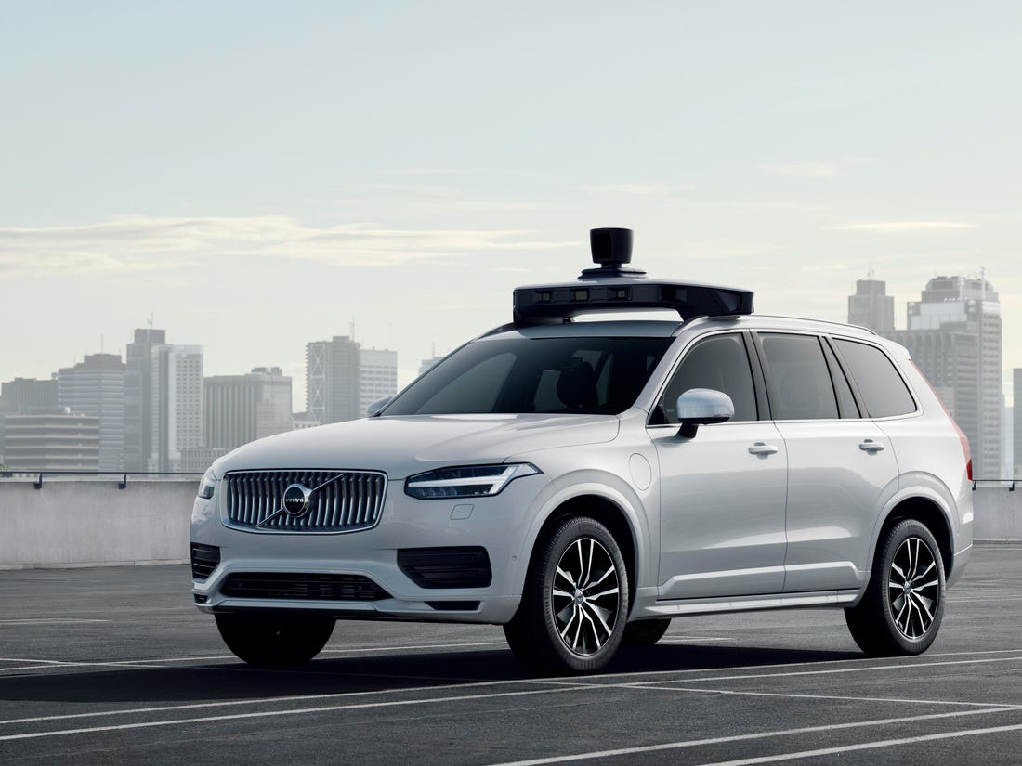

Requirement

1. In Phase 1 the car has to travel through the entire world and generate a map of the world
2. The map has to include the ‘Start’ location, 5 checkpoints and the ‘End’ locations
3. In Phase 2 the car will start from ‘Start’ location, go to ‘Checkpoint1’, then ‘Checkpoint2’. Similarly after completing all the checkpoints sequentially, go to ‘End’ location
4. In Phase 3 the car will start from ‘Start’ location, take the shortest path to travel through all the checkpoints to finally reach the ‘End’ location

An environment is provided which is built on Blender 2.79.

**To use the environment follow the following instructions:**

1. 'mobot.py' is the module code used to communicate with the environment via json

the necessary json are already available

1. 'example.py' is the program which explains how to use the mobot.py module
2. 'draw_lidar.py' is the program used to represent the Lidar data on Tkinter screen (Lidar data is fetched from the lidar.json file. This is just for verification purpose. This is not live update. You need to rerun the python program after running the ‘getLidar’ function to view the updated Lidar map)

**To use the environment**

-Use the [link](https://download.blender.org/release/Blender2.79/) to download the Blender 2.79 software. Download the appropriate zip file and extract the file(Download zip file only)

-Download the Autonomous Car package from the following [link](https://drive.google.com/drive/folders/1sgzUxSgXekH83ze8aribbFsIOULoQunJ?usp=sharing). Copy the content to Blender 2.79 folder

-Run 'blender.exe'

-In blender open file 'Autonomous_Car.blend' in the same folder

-When ready for simulation click 'p' button on keyboard

-If any time during execution, you want to stop the simulation click 'esc' button to stop the simulation

Once all the phases are done, submit the python program used to do the autonomous driving along with the 8 files shared in ‘Autonomous_Car’ folder